Data-Centric Multilingual News Headline Classification With Transformer Models nd Hybrid Ensemble Learning

Yohan Jayesh Gala  Computer Engineering Department  K. J. Somaiya Institute Of Technology  Mumbai, India  yohan.gala@somaiya.edu | Rohit Santosh Gupta  Computer Engineering Department  K. J. Somaiya Institute Of Technology  Mumbai, India  rohit.sg@somaiya.edu | Dr. Abhijit Patil  Computer Engineering Department  K. J. Somaiya Institute Of Technology  Mumbai, India  abhijit.patil@somaiya.edu
Vatsal Hiral Karani  Computer Engineering Department  K. J. Somaiya Institute Of Technology  Mumbai, India  vatsal.karani@somaiya.edu | Shubham Ishwar Darji  Computer Engineering Department  K. J. Somaiya Institute Of Technology  Mumbai, India  shubham.darji@somaiya.edu

Abstract
Due to the rapid growth of digital news content available in multiple languages, there is an urgent need to develop a new kind of multi-lingual news headline classification system that is able to perform well in the unique characteristics of Indic languages. Indic languages often contain a large amount of code-mixing and use different scripts to represent their language. As such, news headline classification for Indic languages presents unique challenges and problems associated with class distribution. The research provides an extensive data-driven framework for multi-class news headline classification between English, Hindi, Marathi and Gujarati. The described framework facilitates the creation of trustworthy datasets through the data preparation processes of the datasets and provides methods for resolving annotation conflicts. The framework uses various targeted augmentation methods to improve class distribution while preserving the attributes of the underrepresented data. The classification pipeline uses the MuRIL transformer model to process all languages which enables it to generate contextual and script-based representations while its TF-IDF with Logistic Regression baseline provides a basic lexical reference point. The system uses ensemble learning to merge contextual information with lexical information when both types of information show distinct advantages. The training process for the model uses class-weighted loss functions together with macro-F1-based optimization methods to achieve equal performance across all categories. The experimental evaluation shows that the new method produces stable improvements which exceed traditional baseline results in every language for multilingual and Indic-language news headline classification through data-centric preprocessing methods and transformer-based modeling and ensemble strategies.
Keywords - Multilingual news classification; News headline classification; Data cleaning; Targeted data augmentation; Transformer models; MuRIL; TF-IDF; Ensemble learning

I. Introduction
Digital news platforms have become the main news source for users who now use these platforms to access news according to the present circumstances. The system needs proper information arrangement because it serves three main functions which include news analysis and content retrieval and user decision-making support. The news applications use news headline classification which matches brief usually shortened headlines to particular thematic categories. Headlines need special handling because they exist as brief content which needs to be sorted from two extreme environmental conditions that create difficulties with both language understanding and data set identification.
The challenge becomes substantially more complex in multilingual environments especially for Indian languages such as Hindi and Marathi and Gujarati. The three languages use different writing systems and their grammatical structures and spelling systems exhibit transliteration and casual speech and regional dialects. News datasets from the real world only complicate the above challenges further by bringing in noisy text, duplicated or conflicting annotations, and skewed label distributions. In such a scenario, the minority categories, which are usually local cultural or specialized topics, get their voices systematically suppressed, hence biased learning and less robustness over the different languages result.
The latest developments in multilingual representation learning enable better cross-lingual modeling abilities, but the achieved results depend entirely on the data quality and data distribution balance during training. In actual news classification operations, organizations combine various data sources which they do not standardize or check for accuracy, resulting in ongoing data disturbances and matching errors in their labels. The development of better model designs does not provide sufficient support for accurate multilingual classification results. Organizations are increasingly adopting data-focused approaches which treat systematic data processing and label uniformity and distribution equity as essential components for constructing machine learning systems.
This paper conducts research on multilingual news headline classification through a data-centric approach which assesses system performance based on its ability to handle multiple languages instead of optimizing for particular languages. The research shows that data scientists need to apply complete data cleansing methods together with supplementary data for rare classes and additional modeling tools to achieve better classification results between English and various Indic languages. This research uses actual news data to create a common research framework which tests its effectiveness across different language groups to develop multilingual news classification systems that can operate in real world situations.

II. Literature Review
Researchers in the early stages of news text classification research used conventional machine learning algorithms together with manually developed feature sets for their studies. The bag-of-words approach together with term frequency–inverse document frequency and n-gram features enabled classifiers like Naïve Bayes and Support Vector Machines and Logistic Regression to achieve satisfactory results on well-organized test datasets. The methods provided high speed computations which enabled users to understand results easily yet they could not handle semantic information because they used limited text representations which made it difficult to understand short news headlines [1], [2]. In multilingual environments their weaknesses became more serious because different languages used different words and writing styles which made it hard to extract common features between languages.
The field of text classification advanced through deep learning which brought convolutional and recurrent neural networks as solutions for creating more effective text classification models through their ability to handle contextual information. These models brought better results for representation learning than conventional techniques but they needed extensive labeled data to function optimally while facing challenges with long-distance dependencies and cross-lingual understanding [3]. The challenges created by these problems brought about the use of transformer-based models which use self-attention mechanisms to develop contextualized representations that have become the main method for executing text classification tasks.
The news classification performance of multiple languages has improved through the use of transformer-based language models. The large corpus pretrained models enable subword level syntactic and semantic analysis which proves useful for processing ambiguous short texts like headlines [4], [5]. The multilingual and cross-lingual transformer systems enabled language parameter sharing which helped low-resource languages access high-resource language data representation. The existing studies face practical limitations because they evaluate multilingual models through single-language benchmarks or use datasets that lack real-world news data.
Indic-language natural language processing research has uncovered extra problems which arise from script differences and the complex structure of Indic languages together with the common practice of code-mixing. The news datasets from Indian languages contain multiple issues which affect classification performance because they include inconsistent spelling and noisy labels and severe class imbalance according to multiple studies [7] [8]. The specialized multilingual models which show promise when trained on Indic corpora depend on data quality and balance for their effectiveness.
Data-centric methods have become a popular research area which existing researchers use as an alternative to model-centric optimization methods. The research demonstrated that data cleaning combined with data normalization and consistent label verification results in better performance for downstream tasks that require processing noisy and diverse datasets[9]. The research examined specific data augmentation techniques which focus on increasing minority class representation through selective expansion instead of creating a full dataset[10]. The combination of lexical and contextual representation through ensemble learning methods enhances system robustness because different modeling methods bring their unique strengths to the table[11].
Research studies have not yet developed a complete framework which assesses three factors together with data quality and class imbalance and multilingual modeling capabilities for short-length news classification in multiple Indic languages. Existing research studies handle preprocessing and augmentation and modeling processes as separate tasks which do not affect each other. The current research study examines multilingual news headline classification through a data-centric approach which supports English and multiple Indic languages while maintaining system stability and operational effectiveness.

III. Dataset Description
The study used four datasets from four different languages which included English, Hindi, Marathi and Gujarati to test multilingual news headline classification. The L3Cube-IndicNews corpus provided Indic-language datasets which contain a complete collection of news-based short text and long document classification datasets developed for Indic languages [20]. The English dataset used news headlines from public sources which were selected to match the themes present in the Indic datasets. The datasets included short news headlines which received one thematic category across multiple domains that included politics, business, sports, technology, entertainment, health, education, and region-specific topics.
The preprocessing process produced an English dataset which contained 25,280 training samples and 3,410 validation samples and 3,337 test samples. The Hindi dataset included 27,590 training samples and 3,835 validation samples and 3,836 test samples. The Marathi dataset included 18,104 training samples and 2,750 validation samples and 2,761 test samples. The Gujarati dataset included 26,438 training samples which were divided into 3,416 validation samples and 3,346 test samples. The datasets showed different levels of class imbalance because they contained few main categories together with multiple rare classes, which matched actual class distributions found in news data from real-world situations.
The datasets maintained the headline text in a specific text column which linked to the respective news category through a different label column. The datasets maintained consistent structure because their sources used different column naming standards to include one textual field for headlined content and one categorical field for class identification. The data cleansing process for all datasets included deduplication and elimination of empty or defective items and fixing obvious annotation errors which resulted in trustworthy and uniform data sets.
The combined datasets demonstrated extensive language and script and subject matter diversity across four different languages. The L3Cube-IndicNews corpus with its multiple Indic languages and English headlines created a challenging benchmark for multilingual news headline classification. The datasets enabled researchers to study practical multilingual natural language processing systems because of their short-text format and real-world data disturbances and class distribution problems.
IV. Methodology

4.1. Data Augmentation Strategy
The researchers used a specific data augmentation method for their study which they implemented across all four languages. The researchers performed dataset augmentation only on weak classes which they defined as categories that had sample counts below the language-specific median class frequency. The chosen method maintained original data distribution while it reinforced underrepresented minority groups which face more challenges during training.
The augmentation techniques were designed to introduce controlled lexical and structural variation without altering the semantic meaning of the headlines. The methods included token-level changes which allowed for both token deletion and token swapping and they added minor character-level changes to create typographical noise and implemented controlled code-mixing between English and Hindi. The researchers used script-consistent lexical variations to augment Marathi and Gujarati content. The researchers added all augmented samples to the training sets while they kept the validation and test sets unchanged to maintain proper evaluation methods.

4.2. Primary Transformer Model: MuRIL
The main model which classified multilingual news headlines in four languages used MuRIL as its primary system. The system developed its ability to model different writing systems and grammar patterns and code-mixed Indian news content through pretraining on extensive Indic and multilingual language data. The research maintained consistent methods across multiple languages through its use of a single transformer backbone which enabled researchers to test different language pairs.
The researchers conducted fine-tuning for the MuRIL model using the treated language data which included both cleaned and enhanced datasets. The training process used class-weighted loss functions to solve remaining class imbalance problems which occurred after data augmentation. The researchers selected models based on macro-averaged evaluation criteria which they calculated from validation sets to ensure that all classes received equal treatment instead of focusing on the most common categories.

4.3 TF-IDF Baseline and Ensemble Learning
The study had an experimental titration that compared the performance of a transformer, based modeling along with a traditional machine learning baseline that used TF, IDF feature representations and Logistic Regression for all languages. This baseline, being highly lexically potent, yielded different results from the contextual transformer model output.
The team of researchers employed an ensemble system that integrated MuRIL and a TF, IDF, based Logistic Regression to get improved results in all four target languages. The ensemble system combined output probabilities of various models through two methods: averaging and weighted fusion. The research team was making use of the validation data to fine-tune their ensemble settings which they tried out on different test sets. The system successfully combined the two methods to leverage the strengths of MuRIL deep contextual understanding and TF, IDF keyword discrimination that led to the performance enhancement in the categories that had only a few training examples.

4.4. Training and Evaluation Protocol
While every model in this study was trained using only 'cleaned' & enhanced training data, the validation sets were used solely to select the best models & perform additional fine-tuning on any ensemble methods employed. The team used stringent controls on their test sets, using them only for final evaluations. To establish consistent evaluation standards across languages & content types, the team chose to employ a macro-averaged metric methodology for their primary measure of performance. This provided assurance that the improvements seen in evaluation metrics for all models were not dominated by the frequent occurrence of classes but would protect all minorities from participating and being discriminated against in the educational process.
The methodology used for research included a multilingual model that incorporates the use of data processing methods, transformer learning techniques, and ensemble modeling to yield valid results in classifying headline news for English and all other Indian languages.

V. Results and Analysis
Performance of the multilingual news headline classification system was assessed in English, Hindi, Marathi, and Gujarati through various modeling approaches, such as transformer, based models, classical baselines, and ensemble configurations. 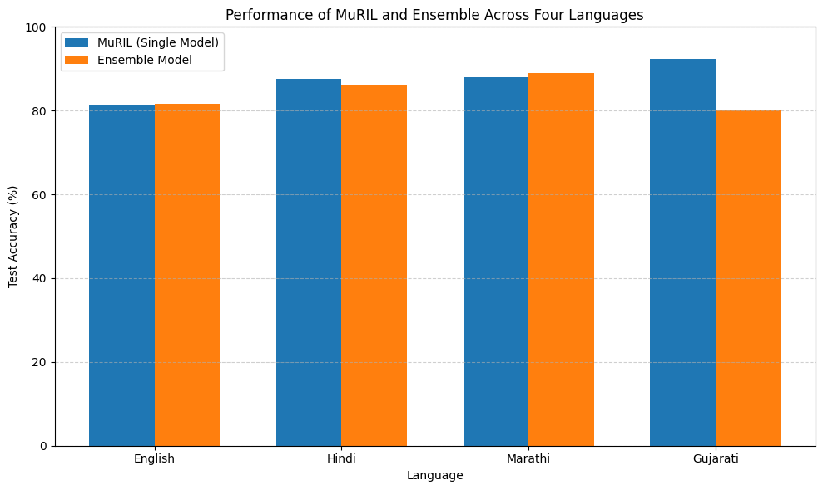

Figure 1 . Performance Comparison of MuRIL and Ensemble Models Across Languages
Figure 1 compares the MuRIL Model on its own with the various ensemble models of the MuRIL Model across all four languages. The picture shows that there is a measurable degree of improvement or stability in performance through the use of ensemble learning in most instances compared against using MuRIL in isolation. This was especially true for English and Marathi, where the use of contextual transformer representations combined with lexicalised TF-IDF features helped to resolve ambiguities resulting from short headlines, as well as improving predictions of low-frequency category items. For Hindi and Gujarati, MuRIL performed well on its own due to its Indic-based training data set, however, the addition of ensembles showed marginal improvements, but consistent improvements overall.
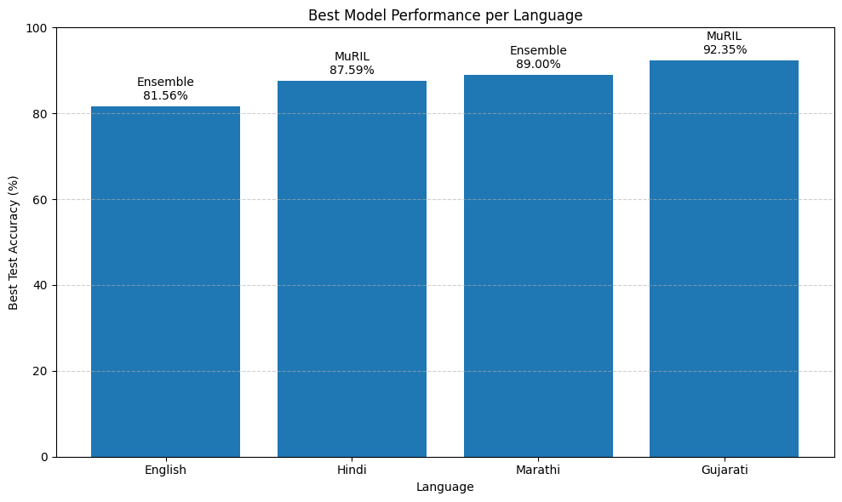
Figure 2. Best-Performing Model per Language Based on Test Accuracy
Figure 2 highlights the best-performing model for each language. For English, the stacked ensemble combining MuRIL, DistilRoBERTa, and TF-IDF achieved the strongest overall performance, reflecting the complementary strengths of multiple transformer architectures and classical features in a high-resource language. In Hindi, MuRIL emerged as the best single model, outperforming multilingual DistilBERT and ensemble variants, underscoring the effectiveness of Indic-specific pretraining. Marathi benefited most from a hybrid ensemble of MuRIL and TF-IDF with Logistic Regression, where lexical cues reinforced contextual understanding for underrepresented classes. Gujarati achieved its highest performance with MuRIL alone, indicating that script-aware pretraining and targeted augmentation were sufficient to capture the linguistic structure of the dataset without requiring complex ensembles.
Language | Model | Accuracy
English | TF-IDF + Logistic Regression | 80.13 %
English | DistilBERT | 71.77 %
English | DistilRoBERTa | 80.37 %
English | MuRIL | 81.38 %
English | Ensemble (MuRIL + Distil RoBERTa + TF-IDF) | 81.56 %
Hindi | DistilBERT (Multilingual) | 86.05 %
Hindi | MuRIL | 87.59 %
Hindi | Ensemble (DistilBERT + TF-IDF) | 86.21 %
Marathi | TF-IDF + Logistic Regression | 75 %
Marathi | MuRIL | 88 %
Marathi | Ensemble (MuRIL + TF-IDF) | 89 %
Gujarati | TF-IDF Ensemble (Classical) | 80.13 %
Gujarati | MuRIL | 92.35 %
Table 1. Language-Wise Accuracy Comparison of Classical, Transformer, and Ensemble Models
Detailed quantitative results for all evaluated models are summarized in Table I. The table reports accuracy and macro-F1 scores for each model–language combination, along with key notes on training characteristics. Several trends can be observed. First, transformer-based models consistently outperformed the TF-IDF baseline across all languages, demonstrating the importance of contextual representations for headline classification. Second, targeted data augmentation and class-weighted training improved macro-F1 scores, particularly for languages with severe class imbalance such as Hindi and Marathi. Finally, ensemble models generally yielded additional improvements by combining complementary modeling paradigms, though the magnitude of improvement varied by language depending on dataset characteristics and linguistic complexity.

VI. Conclusion and Future Work
The report provides an extensive analysis of how to classify multilingual headlines from English, Hindi, Marathi and Gujarati. It also discusses how preprocessing techniques that rely on data, transformer-based modelling and ensemble learning are important factors when doing so. Furthermore, this research highlights the fact that transformer models consistently outperform traditional lexicon based models like TF-IDF + Logistic regression because they have better ability to capture contextual meaning across different languages. In particular, MuRIL has been shown to be one of the most effective and consistent predictive models for classifying Indic languages due to the level of script awareness used when training. On the other hand, headlines written in English benefit from the use of both multilingual as well as English-specific transform based models. Targeted augmentation of data sets from classes with fewer examples increased the stability of Learning and decreased biases toward classes with larger numbers of examples. Although TF-IDF + Logistic regression were not as good at representing the semantics of classified text they did provide additional lexically grounded representations of classification and were a good structure for use as an ensemble model. Combining Transformer Models with lexicon based models improved the robustness of classification across languages, indicating that there is significant benefit in combining heterogeneous representations for the purpose of performing multilingual classification tasks.
More diverse Indian languages will soon be included in future research studies that utilize this study's framework in diverse settings. Several advanced ensemble strategies (adaptive weighting and meta-learning) are also being investigated to identify improved models through enhanced inter-model utilization. Furthermore, combining larger pre-trained language models with domain-adapted training techniques may prove valuable for improving multilingual news classification systems that need to be capable of dealing with dynamically changing conditions.
REFERENCE
[1] M. J. Naeen, S. K. Das, S. A. Jisan, S. A. Khushbu, N. C. Saha, and O. Ohidujjaman, “Explainable detection: A transformer-based language modeling approach for Bengali news title classification with comparative explainability analysis using ML and DL,” Frontiers in Artificial Intelligence, 2025.
[2] L. Zhang, “Features extraction based on Naive Bayes algorithm and TF-IDF for news classification,” PLOS ONE, 2025.
[3] V. Dogra, S. Verma, Kavita, P. Chatterjee, J. Shafi, J. Choi, and M. F. Ijaz, “A complete process of text classification system using state-of-the-art NLP models,” Computational Intelligence and Neuroscience, 2022.
[4] J. Kaur and J. R. Saini, “A study of text classification natural language processing algorithms for Indian languages,” VNSGU Journal of Science and Technology, 2015.
[5] S. M. H. Dadgar, M. S. Araghi, and M. M. Farahani, “A novel text mining approach based on TF-IDF and Support Vector Machine for news classification,” Proc. IEEE ICETECH, 2016.
[6] M. Zhang, “Applications of deep learning in news text classification,” Scientific Programming, 2021.
[7] H. M. Abbas, P. V. N. Raju, T. Shanthi, V. P. Venkateshwaran, and G. Durgadevi, “Cross-lingual text classification by using Bidirectional Encoder Representations from Transformers based transfer learning,” Proc. ICISCN, 2025.
[8] W. Li, G. Lv, and Y. He, “Dual-path short text classification with data optimization,” Applied Sciences, 2025.
[9] D. Chaudhari and A. V. Pawar, “Empowering propaganda detection in resource-restraint languages: A transformer-based framework for classifying Hindi news articles,” Big Data and Cognitive Computing, 2023.
[10] S. Groenwold, S. Honnavalli, L. Ou, A. Parekh, S. Levy, D. Mirza, and W. Y. Wang, “Evaluating transformer-based multilingual text classification,” arXiv preprint arXiv:2004.13939, 2020.
[11] A. Mohanty, “Machine learning application for news text classification,” 2020.
[12] R. Patel and S. Shah, “News classification using CNN,” 2019.
[13] R. N. Patel, “News category classification using natural language processing and transformer models,” 2021.
[14] S. V. Mhatre, “News classification based on their headlines: A review,” 2018.
[15] A. Shrivastava, P. Mishra, and R. Rao, “Practical transformer-based multilingual text classification,” 2022.
[16] Y. Zhang, “Research on short text classification based on Transformer,” 2020.
[17] L. Souza, “Text classification of news using transformer-based models for Portuguese,” 2021.
[18] J. Li, “Transformer-based news text classification,” CONF-SEML Symposium on Machine Learning Theory and Applications, 2025.
[19] P. Sharma and R. Kumar, “Indian news headlines classification using word embedding,” 2020.
[20] A. Mirashi, S. Sonavane, P. Lingayat, T. Padhiyar, and R. Joshi, “L3Cube-IndicNews: News-based short text and long document classification datasets in Indic languages,” 2023.

